calculate_power.R

Samuel

Thu Oct 11 20:41:26 2018

##### Calculate Power for Varying Sample Sizes  
n.options = seq(2,20,by=1)   
res.power = NA  
  
for(i in 1:length(n.options)) {   
 res = power.anova.test(groups=4,   
 between.var=var(c(22, 23, 29, 30)),   
 within.var = 5,   
 sig.level=0.05,   
 n=n.options[i])  
 res.power[i] = res$power   
}  
plot(n.options,  
 res.power,  
 type="l",   
 xlab="Sample Size",   
 ylab="Power",   
 main="Power Curve for Cookie Type Study")  
  
# Part b  
power.anova.test(groups=4,   
 between.var=var(c(22, 23, 29, 30)),   
 within.var = 5,   
 sig.level=0.05,   
 power = 0.85)

##   
## Balanced one-way analysis of variance power calculation   
##   
## groups = 4  
## n = 2.465873  
## between.var = 16.66667  
## within.var = 5  
## sig.level = 0.05  
## power = 0.85  
##   
## NOTE: n is number in each group

# Part c  
n.options = seq(2,20,by=1)   
res.power = NA  
  
for(i in 1:length(n.options)) {   
 res = power.anova.test(groups=4,   
 between.var=var(c(30, 29, 23, 22)),   
 within.var = 5,   
 sig.level=0.05,   
 n=n.options[i])  
 res.power[i] = res$power   
}  
plot(n.options,  
 res.power,  
 type="l",   
 xlab="Sample Size",   
 ylab="Power",   
 main="Power Curve for Cookie Type Study")

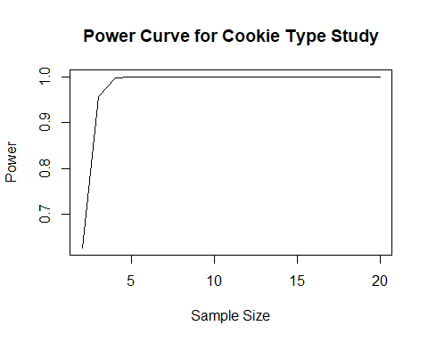

# Part d  
n.options = seq(2,20,by=1)   
res.power = NA  
  
for(i in 1:length(n.options)) {   
 res = power.anova.test(groups=4,   
 between.var=var(c(21, 26, 26, 31)),   
 within.var = 5,   
 sig.level=0.05,   
 n=n.options[i])  
 res.power[i] = res$power   
}  
plot(n.options,  
 res.power,  
 type="l",   
 xlab="Sample Size",   
 ylab="Power",   
 main="Power Curve for Cookie Type Study")